Real-Time Crowd Risk Prediction and Safety Management Using Deep Learning and Generative AI
Dwarakesh Venkateshan  UG Student  Department of Artificial Intelligence and Machine Learning  Vel Tech Rangarajan Dr. Sagunthala R&D Institute of Science and Technology, Chennai, India  dwarakeshoff@gmail.com | Nallamilli Bhavana Gayatri  UG Student  Department of Artificial Intelligence and Machine Learning  Vel Tech Rangarajan Dr. Sagunthala R&D Institute of Science and Technology, Chennai, India  bhavanac1439@gmail.com | Alex David S  Professor  Department of Artificial Intelligence, Machine Learning  Vel Tech Rangarajan Dr. Sagunthala R&D Institute of Science and Technology, Chennai, India  adstechlearning@gmail.com
Name  Designation  Department  Institution  City, Country  email | Name  Designation  Department  Institution  City, Country  email | Name  Designation  Department  Institution  City, Country  email

Abstract - Fatal crowd incidents rarely stem from an absence of cameras; affected venues are usually under continuous surveillance at the time, which places the failure in the conversion of observation into timely, specific and defensible action. This paper presents CrowdGuard-RAG, which treats crowd safety as a decision-latency problem. Density is estimated per person on the ground plane through a planar homography and a k-nearest-neighbour estimator, so persons per square metre is a physical quantity comparable against published safety bands. An eight-class failure-mode taxonomy, in which each class is gated on a physically necessary precondition, separates hazards that yield similar scalar risk but demand opposite responses, such as a progressive crush and a panic dispersal. A temporal transformer forecasts the fused risk thirty seconds ahead and reports a time-to-threshold, and recommendations are grounded by retrieval over the venue's own procedures so every instruction carries a citation. Evaluated on an agent-based simulator supplying ground truth across eight scripted scenarios and three seeds, the system attains a counting MAE of 4.78 persons (3.0 % MAPE) with density correlation r = 0.926, identifies the intended failure mode in seven of eight scenarios (72.9 % frame-level), reaches retrieval Precision@1 of 0.800 and MRR 0.831, and forecasts with MAE 0.0795 against a persistence baseline of 0.1312 (skill +0.394) at 56.5 fps with zero alert flapping. Limitations are reported explicitly, including a measured under-reporting of 1.09 persons per square metre inside the crush band.
Keywords - Crowd safety, crowd crush, ground-plane density, crowd turbulence, failure-mode classification, risk forecasting, retrieval-augmented generation, explainable decision support
https://github.com/DWARAKESH8/BATCH-2-MAJOR-PROJECT-2026-2027

I. INTRODUCTION
Mass gatherings concentrate very large numbers of people into constrained spaces, and the resulting densities can move from comfortable to lethal within a minute. As local density passes roughly five persons per square metre, individuals lose the ability to control their own position, contact becomes involuntary, and small disturbances propagate as pressure waves through the packed crowd; death is predominantly by compressive asphyxia rather than trampling. A common objection to automated monitoring is that a human watching the same video can recognise a dangerous crowd unaided, but the objection is empirically weak. Venues at which fatal incidents occurred were, in the substantial majority of documented cases, under closed-circuit surveillance with staffed control rooms; the video existed and was being watched. A large venue may operate several hundred cameras against fewer than ten operators, so the probability that the informative camera is on the primary display during the critical ninety seconds is low. Most importantly, the variable that predicts a crush is not one a human can estimate: crowd turbulence arises from the product of local density and the variance of local velocity, which cannot be judged by eye, and a dense crowd moving coherently is markedly safer than a sparser crowd containing opposing streams.
This work reframes the task as closing four gaps between observation and action: an observation gap, in which the informative camera is unwatched; a quantification gap, in which the operator holds an impression rather than a measurement that can cross a threshold; an interpretation gap, in which a density means nothing without knowing what is normal for that gate; and an action gap, in which the correct procedure sits in a document that cannot be read in thirty seconds. The contributions are a ground-plane density estimator yielding per-person local density in physical units; an eight-class failure-mode taxonomy gated on necessary physical preconditions; a temporal transformer forecasting risk thirty seconds ahead with a time-to-threshold; retrieval-grounded advisory generation over venue procedures; and an escalation controller with hysteresis and dwell time. Section II surveys recent work, Section III the method, Section IV results and limits, and Section V concludes.

II. RELATED WORK
Density-map regression dominates dense-scene counting because detection degrades sharply under mutual occlusion. Benchmarks such as NWPU-Crowd and JHU-CROWD++ extended evaluation to adverse illumination and established localisation alongside counting [1], [2]; point-based frameworks regress head positions directly [3], transformer architectures have improved congested-region performance [4], and surveys document the shift towards attention-based multi-scale designs [5]. These methods report error in units of people and do not output a physical ground-plane density, so their outputs cannot be compared against the density bands used in safety practice. Analyses of crowd accidents compiled from press and official reports establish that the recurring mechanism in fatal incidents is progressive compression at a constriction rather than panic-driven flight [6]; methodological reviews stress the difficulty of obtaining ground truth for dangerous states, which cannot be induced experimentally [7], and Hajj studies provide some of the few large annotated dense-crowd datasets [8]. This literature identifies which quantities matter physically but is largely offline.
Head-tracking datasets exist precisely because full-body detection fails when bodies are occluded but heads remain visible [9], and drone benchmarks such as VisDrone supply the viewpoint relevant to event-security platforms [10]; single-stage detectors remain the practical real-time choice [11]. Transformer forecasters for long sequences are well studied [12], [13], with comparative work cautioning that simple baselines stay competitive [14] - a caution taken seriously here by reporting skill relative to persistence rather than error alone. Retrieval-augmented generation conditions a model on documents retrieved at inference, reducing unsupported output and permitting attribution [15].
Summary of Gaps
Three gaps persist. Counting research reports error in people while safety practice reasons in persons per square metre on the ground plane, and the conversion is seldom addressed. Risk is almost universally reduced to a scalar or a coarse band, which cannot select an intervention, since a progressive crush and a panic dispersal may score alike yet require opposite responses. Finally, systems classifying the present frame provide no warning interval, whereas every physical intervention has a latency of minutes. The system described here is designed around these three gaps.

III. PROPOSED METHODOLOGY
The pipeline converts a frame into an attributable instruction through detection, ground-plane projection, density and pressure estimation, movement-quality measurement, failure-mode classification, forecasting and retrieval-grounded generation, followed by an escalation controller deciding whether and whom to notify (Fig. 1).
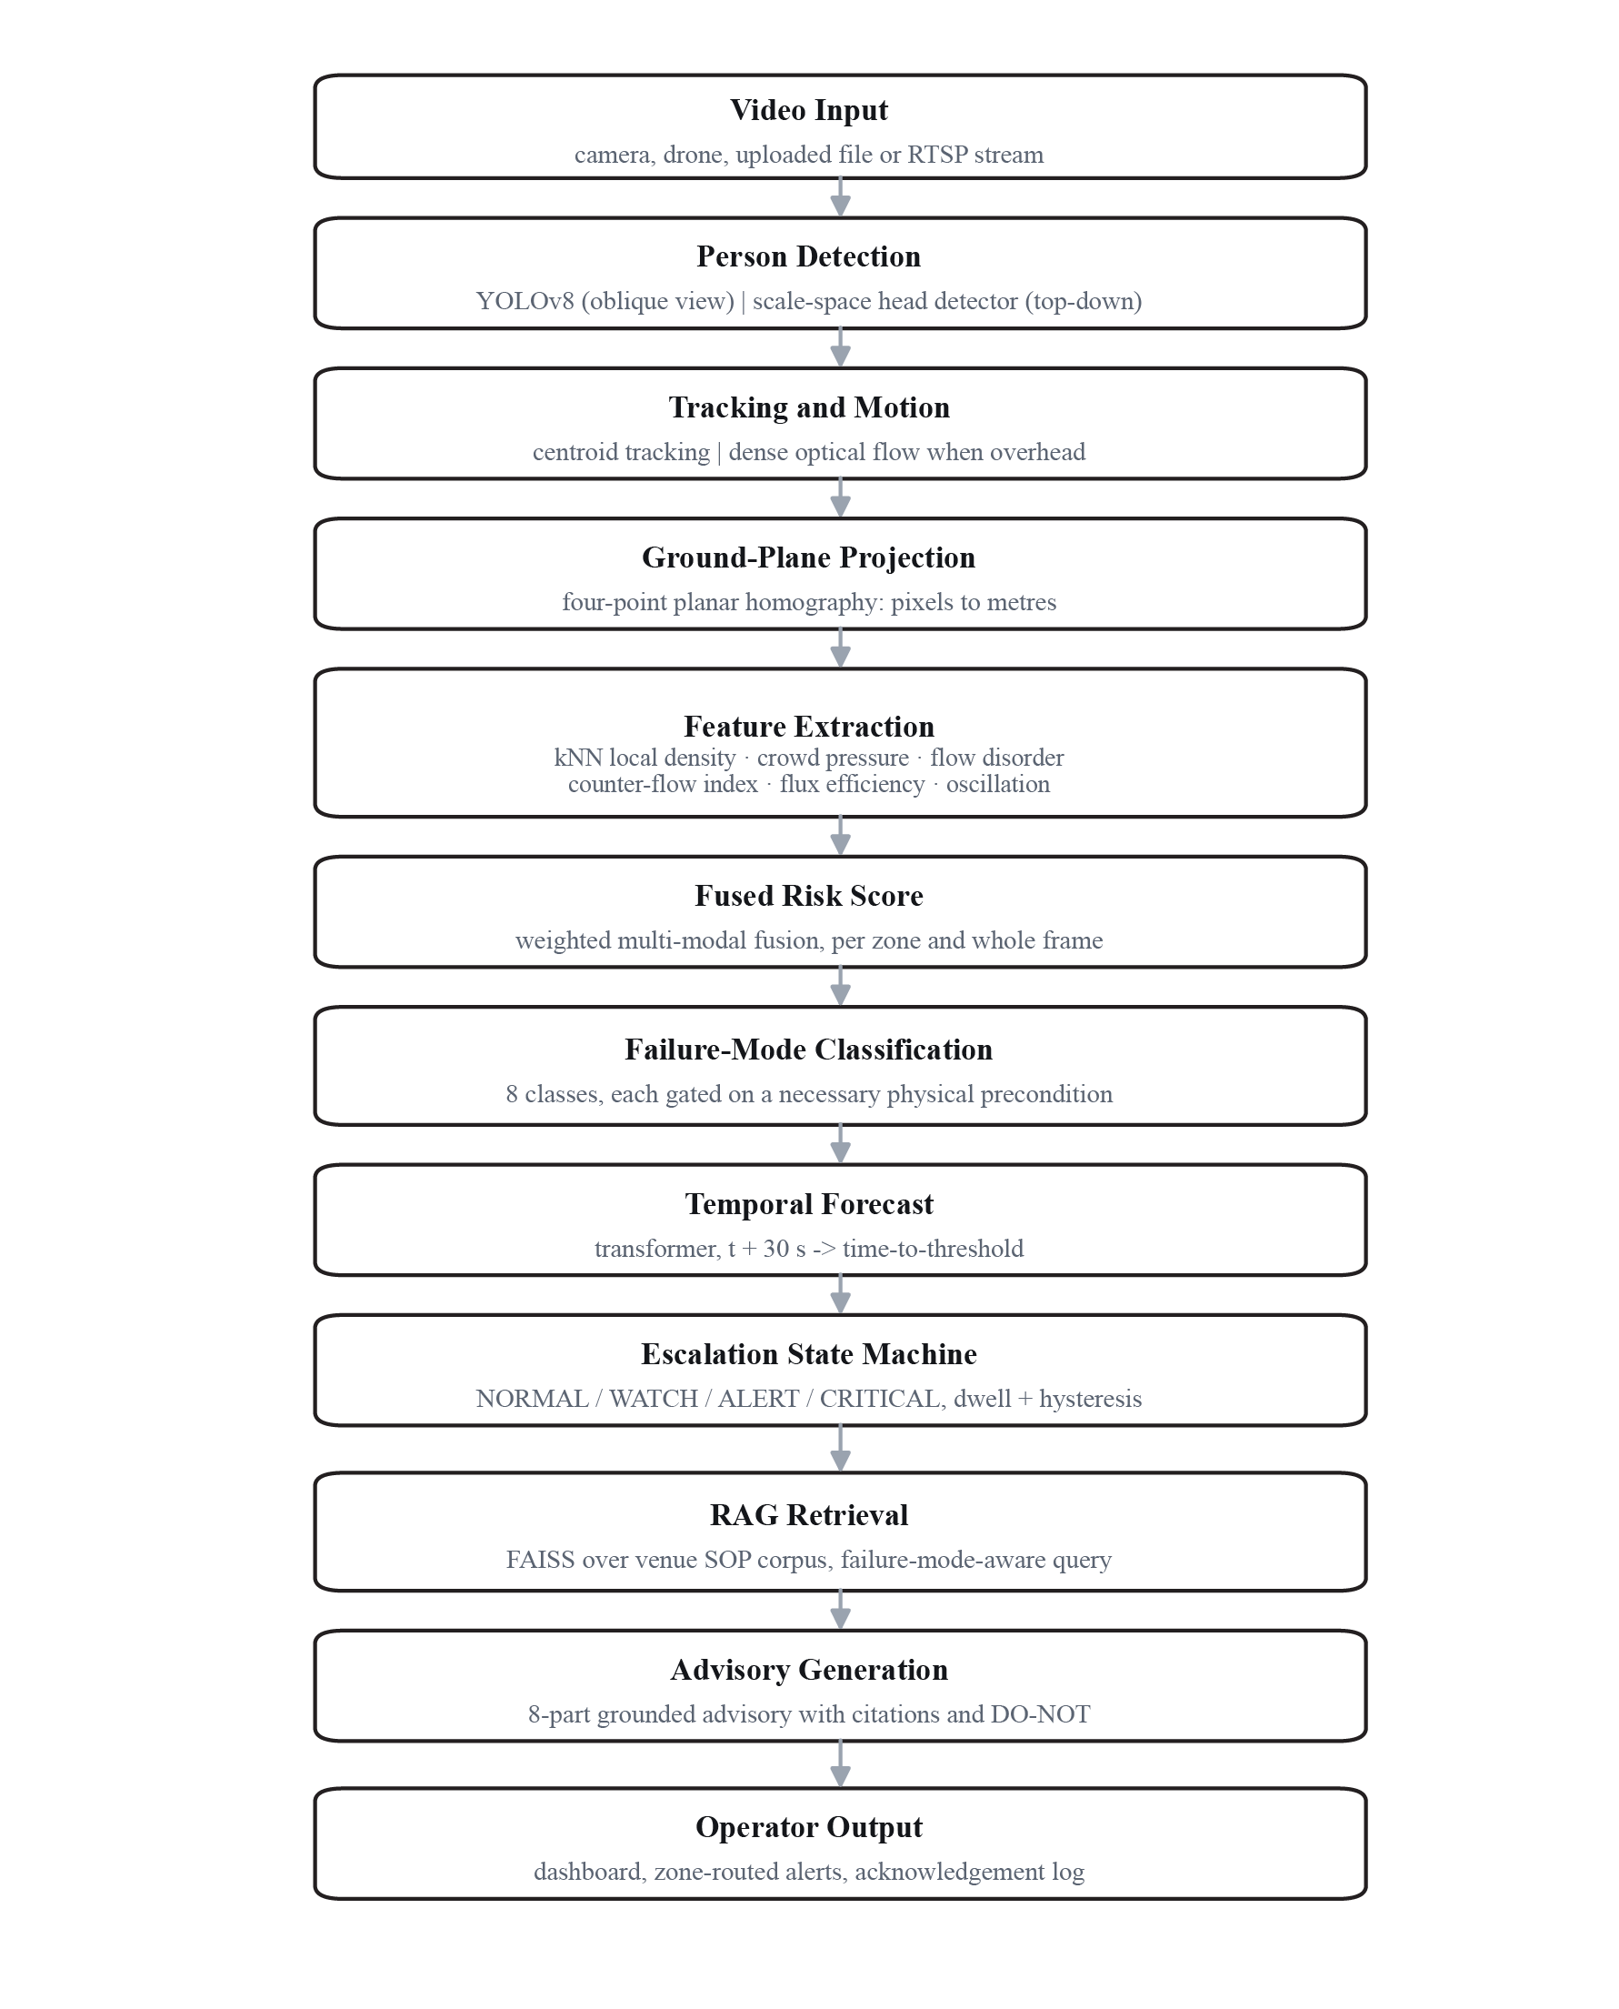
Fig. 1. System architecture. Each stage converts the previous representation into a more decision-ready one: pixels become metres at the ground-plane projection, metres become physical measurements at feature extraction, measurements become a named failure mode and a forecast horizon, and only then is the venue's own procedure retrieved to produce an attributable instruction. Operator acknowledgements return as supervised labels.
A. Detection and View Adaptation
A measured limitation motivates a second detection path. On a synthetic overhead night scene of sixty-nine people, a COCO-trained person detector returned zero detections at confidence 0.30 and still zero at 0.03 - a distribution problem, not a threshold one, since the person class comprises upright bodies with visible torso and limbs whereas a downward camera sees compact head-and-shoulder blobs of four to twenty-five pixels. A scale-space Laplacian-of-Gaussian head detector is therefore provided: a blob of radius r responds most strongly at a Gaussian standard deviation of r over root two, so sweeping scale locates head-sized structures independently of altitude. The ground reference also differs by view - obliquely the feet are the ground contact, whereas from above the head lies directly over the feet and the box centre is correct.
B. Ground-Plane Density and Crowd Pressure
Density computed on the image plane is not a physical quantity. A person standing forty metres from the camera occupies a small fraction of the pixels of one standing five metres away, so any measure defined over image area under-reports the far field and over-reports the near field, and cannot be compared against a safety threshold expressed in persons per square metre. The system therefore recovers the mapping between image plane and ground plane. Because a crowd on level ground is to a good approximation a planar scene, that mapping is a planar homography, fully determined by four point correspondences: the operator marks the corners of any ground rectangle of known dimensions - a paving grid, a barrier spacing - and the transform follows by the direct linear transform, after which every measurement is made in metres. Since a miscalibration would silently corrupt every downstream quantity, the residual reprojection error is checked and a calibration exceeding two metres of mean error is rejected in favour of an explicitly flagged approximation, on the principle that a confidently wrong calibration is more dangerous than an acknowledged one.
Frame-global density assigns the same value to an evenly spread crowd and to the same number compressed into a corner, though only the second is dangerous. Density is therefore estimated per person from the distance to the k-th nearest neighbour in ground coordinates, eq. (2), reported as a high percentile rather than the maximum so a single artefact cannot force an alarm.

rho_i = k / (pi r_k(i)^2) (1)
Density alone does not distinguish a safe dense crowd from a lethal one. The quantity that does is crowd pressure, defined in the turbulence literature as the product of local density and the variance of local velocity within a neighbourhood, eq. (2). Its interpretation is physical: a dense crowd moving coherently has small velocity variance and low pressure however packed it is, whereas individuals pushed in conflicting directions raise the variance so that pressure grows multiplicatively with density. This is the mechanism by which a crowd passes from congested to dangerous, and it is precisely the quantity a human observer cannot estimate from a video image.

P_i = rho_i Var(v_j), j in N(i, R) (2)
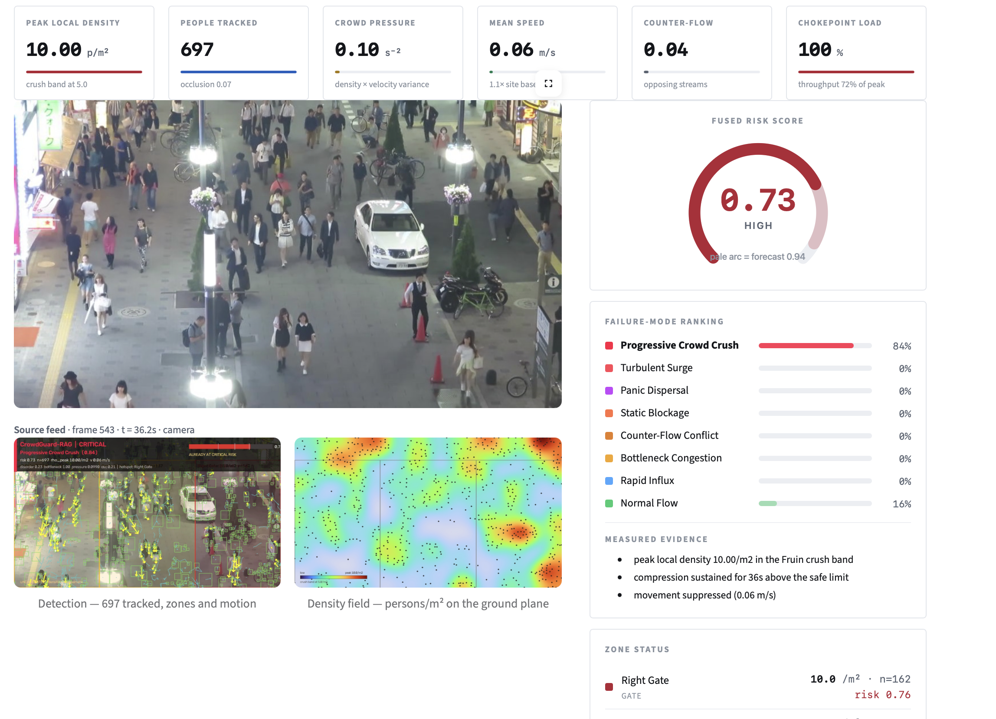
Fig. 2. Detection and tracking output at a critical moment. Bounding boxes mark detected persons, yellow arrows show per-track velocity, coloured polygons are the operator-defined zones with their measured density and occupancy, and the header reports the escalation state, the classified failure mode and the underlying measurements.

A qualification attaches to the threshold rather than the definition. Published critical values derive from optical-flow velocity fields over a smoothed grid, whereas this implementation estimates velocity from tracked centroids at a lower rate, giving a variance on a different numerical scale. Quoting a published threshold against a different estimator would be the right number with the wrong instrument, so operating thresholds are calibrated against this estimator's observed distribution.

C. Movement Quality and Fused Risk
Directional coherence is quantified by comparing the magnitude of the vector sum of all velocities against the sum of their individual magnitudes. When everyone walks the same way the two coincide and the disorder measure is near zero; when motion cancels it approaches unity. This measure is insufficient alone, because a stalled crowd also scores as highly disordered: people shuffle in random micro-directions that cancel just as effectively as two opposing streams, yet the two situations demand opposite interventions. The system separates them using circular statistics on the distribution of velocity directions. The first-order resultant measures whether a single dominant direction exists; the second-order resultant measures whether a dominant axis exists irrespective of sign. A coherent stream scores high on both, scattered motion low on both, and two opposing streams are the only configuration sharing an axis while cancelling in direction - a low first-order with a high second-order resultant. That signature identifies genuine counter-flow.
Two further quantities describe how the crowd evolves rather than how it stands. Pedestrian flux, the product of density and mean speed, rises with density to a critical point then collapses; tracking it against its own running peak detects when throughput has fallen onto the congested branch of the fundamental diagram, distinguishing a busy but discharging chokepoint from one that has failed. Time accumulated above the hard density limit is recorded as sustained compression, since a crush is progressive and builds over seconds whereas a surge is brief and oscillatory. The six normalised features are combined by a weighted sum placing local density and crowd pressure foremost and instantaneous speed last, a weighting the ablation in Section IV confirms.
D. Failure-Mode Classification
A scalar risk value does not determine an intervention, so the hazard is classified into one of eight named failure modes. Each class score is the product of two terms. The first is a gate encoding a physically necessary precondition, expressed as a soft membership function over the measured features: there can be no crush without density in the crush band, and no counter-flow conflict without directional bimodality. The second is a weighted sum of supporting evidence that modulates the score within the range the gate permits. Multiplying rather than adding is deliberate: it guarantees a class can never fire on circumstantial evidence when its necessary condition is absent. The construction is rule-based rather than learned because in a safety-critical setting an operator must be able to ask why a hazard was declared and receive the measurement that triggered it, and the system returns exactly that. Table 1 gives the taxonomy; the crush and dispersal rows show why a single scalar cannot suffice, since both may score highly yet one requires inflow halted and pressure released from the leading edge while the other requires every exit opened.

Table 1: Failure-mode taxonomy, gating conditions and implied response
Failure mode | Necessary gating condition | Primary response (and counter-indication)
Normal Flow | Residual class | Routine monitoring
Rapid Influx | Density rate high, density sub-critical | Meter inflow upstream while it is still cheap
Bottleneck Congestion | Chokepoint loaded, flux on congested branch | Open discharge, hold upstream. Do not narrow the discharge point
Counter-Flow Conflict | High circular bimodality, crowd still moving | Impose one-way movement, separate streams
Static Blockage | High density with near-zero speed | Stop inflow, clear head of jam. Do not reverse a jammed crowd
Turbulent Surge | High density with oscillation or pressure above warning | Stop inflow, break wave laterally. Do not enter against the flow
Progressive Crush | Crush-band density, movement suppressed and sustained | Halt inflow, relieve from the front. Never extract from the rear
Panic Dispersal | Speed surge above baseline with scattering directions | Open all exits, remove source. Do not meter or narrow exits

E. Forecasting, Grounded Advice and Escalation
Classifying the present frame offers an operator no warning interval, yet every physical intervention available to them - closing a gate, opening a diversion route, walking marshals into position, changing behaviour by announcement - has a latency measured in minutes, so an alarm firing when the crowd is already dangerous fires too late to act upon. A temporal transformer consumes a window of the eight-dimensional feature sequence and regresses the fused risk one horizon ahead, defaulting to thirty seconds. Self-attention lets the model weight earlier states by relevance rather than recency, which matters because the precursors of a crush appear well before density becomes extreme. Training uses sequences logged from the system's own runs rather than values sampled from the scoring expression, avoiding the circularity of fitting a model to labels generated by the formula it must predict.
The operationally significant output is not the predicted value but the interval before a threshold is crossed, obtained by projecting the local trend to the escalation boundary. This converts a nowcast into an actionable statement - a critical condition expected within a stated number of seconds - in which form an operator can judge whether an intervention will arrive in time. A recency-weighted least-squares estimator with damped extrapolation is the fallback when no training data exists, and every forecast is scored against the value observed one horizon later, so the confidence band is empirical.
Instructions are grounded by retrieval over the venue's own procedures, chunked with overlap, embedded and indexed for inner-product search with a sparse lexical fallback so the system remains functional offline. The query combines measured features with the vocabulary of the classified failure mode, directing retrieval to that specific hazard rather than generic crowding advice. The advisory has eight parts: situation, failure mode and mechanism, root cause, ranked actions annotated by responsible role, an explicit statement of what must not be done, a crowd broadcast, a time budget, and citations. Grounding is essential rather than cosmetic, since an unattributable instruction is not defensible in an inquiry.
A controller firing whenever a score crosses a line produces alarm flapping, and operators respond by muting the system - the practical mode by which safety systems fail. Dwell time requires a sustained condition; hysteresis places de-escalation below the escalation threshold so a boundary-hovering score cannot oscillate; acknowledgement suppression halts re-notification once accepted. The critical state receives the shortest dwell, since a slow alarm on a crowd already in the crush band is worthless. Acknowledgements persist operator identity, decision and action, serving as an audit trail and as genuine human labels.
Algorithm CrowdGuard_RAG_Cycle
Inputs F: frame; H: homography; Z: zones; KB: procedure index; S: state
1 X = ground_project(centroids(detect(F)), H)
2 rho = knn_density(X, k); V = velocities(X)
3 P = local_pressure(X, V, rho); M = movement_quality(V)
4 R = weighted_fuse(rho, P, M); c = classify(rho, P, M)
5 Rf, t_cross = forecast(history, R)
6 S' = escalate(S, R, dwell, hysteresis)
7 if S'.state != NORMAL:
8 C = retrieve(KB, build_query(rho, P, M, c, Z))
9 A = generate_advisory(c, Z, Rf, t_cross, C); dispatch(S'.events, A)
10 log(features, c, Rf, S', A); return A

IV. RESULTS AND DISCUSSION
A. Experimental Setup
Ground truth for dangerous crowd states is the central obstacle here: such events cannot be induced experimentally, and public video of fatal incidents is neither systematically annotated nor ethically appropriate as a benchmark. An agent-based simulator was therefore developed, its agents following a social-force model whose speed-density relation matches the pedestrian fundamental diagram. It renders frames, emits detections carrying positional noise and occlusion dropout, and records every true position.
Two properties matter. Because true positions are known, the reported density errors are genuine rather than self-consistency checks; and because each scenario is physically scripted to produce one failure mode, with the correct answer fixed before the classifier was applied, the classification result is falsifiable. Eight scenarios ran across three seeds at eight frames per second, giving twenty-four runs and 12,480 frames, evaluated on counting and density accuracy, failure-mode classification, thirty-second forecasting against a persistence baseline, retrieval against a hand-written query set, and per-stage runtime, on a single CPU host with no GPU.
B. Performance Metrics and Results
Table 2: Counting and density accuracy against ground truth (n = 12,429)
Metric | All frames | Crush band (>= 4/m2, n = 4,952)
Count MAE (persons) | 4.78 | -
Count MAPE (%) | 3.0 | 7.2
Density MAE (persons/m2) | 0.99 | 1.74
Density bias (persons/m2) | -0.70 | -1.09
Density correlation r | 0.926 | -
Negative bias indicates systematic under-reporting, increasing inside the crush band where the measurement matters most.
Counting error is low at 3.0 % MAPE and density correlation high at r = 0.926, so the estimator tracks the true field rather than merely population size. However the bias is negative throughout and grows to -1.09 persons per square metre inside the crush band: the system under-reports exactly where that is least acceptable. This follows from mutual occlusion, so reported density is a lower bound, which the interface states when occlusion is high.

Table 3: Failure-mode classification against scripted scenarios (3 seeds)
Scenario | Expected | Predicted | Share | Outcome
normal_flow | Normal Flow | Normal Flow | 69.6 % | Pass
rapid_influx | Rapid Influx | Normal Flow | 48.7 % | Fail
bottleneck | Bottleneck Congestion | Bottleneck Congestion | 70.8 % | Pass
counterflow | Counter-Flow Conflict | Counter-Flow Conflict | 100.0 % | Pass
static_blockage | Static Blockage | Static Blockage | 72.2 % | Pass
turbulent_surge | Turbulent Surge | Turbulent Surge | 66.2 % | Pass
panic_dispersal | Panic Dispersal | Panic Dispersal | 84.8 % | Pass
escalating_crush | Progressive Crush | Progressive Crush | 75.7 % | Pass
Scenario-level accuracy 7/8; frame-level 4,546/6,240 = 72.9 %. Share is the proportion of frames assigned the modal class.
Seven of eight scenarios are identified correctly, and the failure is reported rather than tuned away. Rapid Influx is assigned to Normal Flow in 49 % of frames, an expected consequence of its definition: it fires while density is still sub-critical and only the rate is abnormal, so its evidence is weak precisely because the crowd does not yet look dangerous - the boundary between early warning and false alarm, placed conservatively here. Remaining confusions are physically adjacent rather than arbitrary: Progressive Crush with Turbulent Surge (24 %) and Turbulent Surge with Bottleneck Congestion (30 %), both pairs co-occurring in a developing incident. Counter-Flow Conflict is identified perfectly, supporting the circular-bimodality discriminator, since disorder alone had previously conflated counter-flow with jamming.
Table 4: Thirty-second forecasting and retrieval performance
Forecasting metric | Value | Retrieval metric | Value
Matured forecasts | 6,600 | Queries / indexed chunks | 35 / 43
Forecast MAE | 0.0795 | Precision@1 | 0.800
Persistence-baseline MAE | 0.1312 | Recall@5 | 0.886
Skill score vs persistence | +0.394 | MRR | 0.831
Within 0.10 of actual | 77.8 % | nDCG@5 | 0.842
Median warning lead time | 7 s | Mean query latency | 10.9 ms
No forecast is fitted to the data it is scored against. Lead time measured over the 19 runs reaching the critical state.
The learned model reduces forecast error by 39.4 % relative to persistence, showing the temporal features carry information beyond the current value. The seven-second median lead is modest for a structural reason: the scenarios compress an entire incident into roughly two minutes, so the model must anticipate a regime change from a scene containing little evidence of it, and a longer lead would be expected on a real timeline. Retrieval Precision@1 of 0.800 and MRR of 0.831 indicate the correct procedure is usually ranked first, which is what matters when an operator reads only the top result.
An ablation zeroing each feature's weight in turn confirms the weighting. Crowd pressure is the most influential term, altering the reported risk band in 41.4 % of frames when removed, followed by local density at 35.7 % and flow disorder at 28.5 %, consistent with the literature identifying the first two as the causal variables; mean speed changes the band in only 4.4 %, confirming instantaneous speed alone is a weak indicator. Alert volume is itself a quality measure, since an over-alerting system gets muted: across 25.9 monitored minutes the controller produced 53 state changes, 2.04 per minute, with zero flapping. End-to-end throughput is 56.5 frames per second at 17.7 ms per frame, of which retrieval is 12.6 ms - but retrieval is invoked only outside the normal state, so that cost is incurred exactly when it is useful.

Fig. 3A. Ground-plane density field for the same instant as Fig. 1, rendered separately from the camera image so that the measurement is read as an instrument rather than an illustration. Markers are individual ground positions, the colour ramp is calibrated in persons per square metre, and the concentration at the gate throat is the hotspot the classifier acts on.

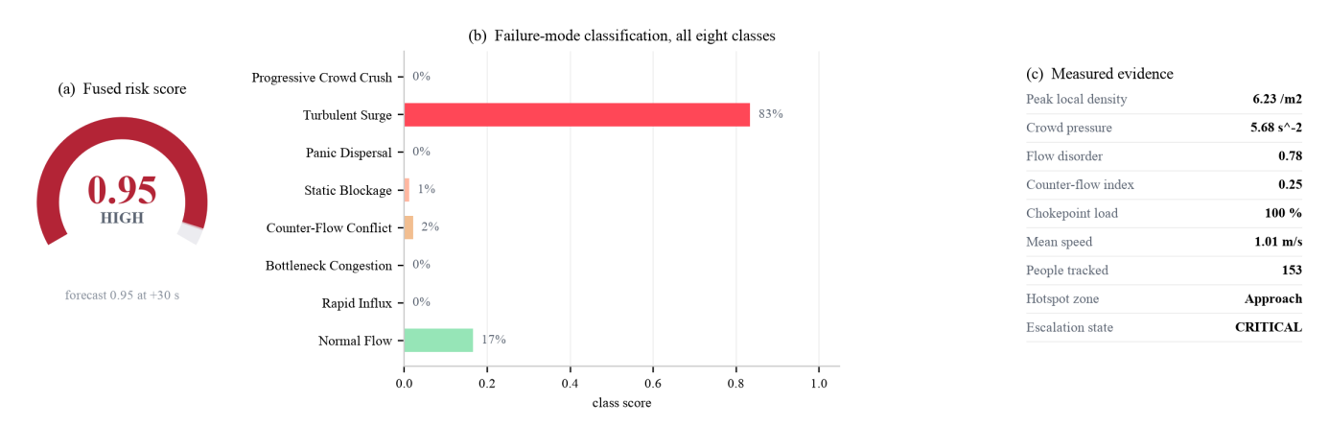
Fig. 3B. Risk assessment for the instant shown in Figs. 1 and 2. (a) the fused risk score with the thirty-second forecast as the pale arc; (b) scores for all eight failure-mode classes, with Turbulent Surge dominant at 0.83 while the physically adjacent classes remain low; (c) the measurements that produced the decision, which the operator can inspect directly.
A separate overhead experiment quantified the viewpoint gap. On synthetic top-down scenes the person detector returned zero detections at confidence thresholds of 0.30, 0.10 and 0.03 alike, failing completely rather than partially, which distinguishes an out-of-distribution input from a merely difficult one. The head detector reached precision 0.99 and recall 1.00 on a sparse overhead night scene of sixty-nine people, but recall fell to 0.51 on a dense aerial scene of 5,508, delimiting detection-based counting at high density and indicating density-map regression as the appropriate estimator there.
Four limitations qualify these results. All measurements are against a simulator written by the present authors, so despite the falsifiable scenarios and genuine ground truth this is not external validation. No headline accuracy is reported for the fused score itself, deliberately: no labelled dataset of true crowd risk exists, so such a figure would require scoring the model against labels it produced. Density is under-reported by 1.09 persons per square metre inside the crush band and is a lower bound, and the pressure threshold is estimator-specific, requiring site calibration. The seven-second lead reflects the compressed scenario timescale, not deployment.

V. CONCLUSION
This paper presented CrowdGuard-RAG, built on the premise that fatal crowd incidents reflect a failure to convert observation into timely action rather than an absence of observation. The system estimates density per person on the ground plane, measures crowd pressure and movement quality including a circular-statistics discriminator that separates opposing streams from jamming, classifies the hazard into one of eight named failure modes each gated on a necessary physical precondition, forecasts risk thirty seconds ahead with an associated time-to-threshold, and grounds every recommendation in the venue's own procedures so instructions carry citations.
Across eight scenarios and three seeds the system achieved a counting MAE of 4.78 persons with density correlation r = 0.926, identified the intended failure mode in seven of eight scenarios at 72.9 % frame-level accuracy, reached retrieval Precision@1 of 0.800 with MRR 0.831, and forecast thirty seconds ahead with MAE 0.0795 against a persistence baseline of 0.1312 at 56.5 frames per second with no alert flapping. It also under-reports density inside the crush band and misclassifies the rapid-influx scenario, both reported rather than concealed. Future work follows: validation on annotated public datasets, an expert-agreement study, a head detector trained on aerial annotations, density-map regression for the dense regime, and operator acknowledgements as labels.

References
- [1] Q. Wang, J. Gao, W. Lin, and X. Li, “NWPU-Crowd: A large-scale benchmark for crowd counting and localization,” IEEE Trans. Pattern Anal. Mach. Intell., vol. 43, no. 6, pp. 2141–2149, Jun. 2021.
- [2] V. A. Sindagi, R. Yasarla, and V. M. Patel, “JHU-CROWD++: Large-scale crowd counting dataset and a benchmark method,” IEEE Trans. Pattern Anal. Mach. Intell., vol. 44, no. 5, pp. 2594–2609, May 2022.
- [3] Q. Song et al., “Rethinking counting and localization in crowds: A purely point-based framework,” in Proc. IEEE/CVF Int. Conf. Comput. Vis. (ICCV), 2021, pp. 3365–3374.
- [4] D. Liang, W. Xu, and X. Bai, “An end-to-end transformer model for crowd localization,” in Proc. Eur. Conf. Comput. Vis. (ECCV), 2022, pp. 38–54.
- [5] G. Gao, J. Gao, Q. Liu, Q. Wang, and Y. Wang, “CNN-based density estimation and crowd counting: A survey,” Neurocomputing, vol. 472, pp. 224–251, 2022.
- [6] C. Feliciani, A. Corbetta, M. Haghani, and K. Nishinari, “Trends in crowd accidents based on an analysis of press reports,” Saf. Sci., vol. 164, p. 106174, 2023.
- [7] M. Haghani, “Empirical methods in pedestrian, crowd and evacuation dynamics,” Saf. Sci., vol. 129, p. 104743, 2021.
- [8] T. Alafif et al., “Hybrid classifiers for spatio-temporal abnormal behavior detection, tracking, and recognition in massive Hajj crowds,” Electronics, vol. 12, no. 5, p. 1165, 2023.
- [9] R. Sundararaman, C. De Almeida Braga, E. Marchand, and J. Pettré, “Tracking pedestrian heads in dense crowd,” in Proc. IEEE/CVF Conf. Comput. Vis. Pattern Recognit. (CVPR), 2021, pp. 3865–3875.
- [10] P. Zhu et al., “Detection and tracking meet drones challenge,” IEEE Trans. Pattern Anal. Mach. Intell., vol. 44, no. 11, pp. 7380–7399, Nov. 2022.
- [11] J. Terven, D.-M. Cordova-Esparza, and J.-A. Romero-González, “A comprehensive review of YOLO architectures in computer vision,” Mach. Learn. Knowl. Extr., vol. 5, no. 4, pp. 1680–1716, 2023.
- [12] H. Zhou et al., “Informer: Beyond efficient transformer for long sequence time-series forecasting,” in Proc. AAAI Conf. Artif. Intell., vol. 35, no. 12, 2021, pp. 11106–11115.
- [13] H. Wu, J. Xu, J. Wang, and M. Long, “Autoformer: Decomposition transformers with auto-correlation for long-term series forecasting,” in Adv. Neural Inf. Process. Syst. (NeurIPS), vol. 34, 2021, pp. 22419–22430.
- [14] A. Zeng, M. Chen, L. Zhang, and Q. Xu, “Are transformers effective for time series forecasting?” in Proc. AAAI Conf. Artif. Intell., vol. 37, no. 9, 2023, pp. 11121–11128.
- [15] Y. Gao et al., “Retrieval-augmented generation for large language models: A survey
- ,” arXiv preprint arXiv:2312.10997, 2024.

